**Real World Analytics**

**End Term Assignment**

**Saurabh Dharmadhikari**

|  |  |
| --- | --- |
| Question 1. | 3 |
| Question 2. | 6 |
| Question 3. | 9 |

Table of Content:

**Question.**

**1. A garment factory produces shirts and pants for Kmart chain. The contract is such that**

**quality control is done before shipping and all products supplied to Kmart satisfying the**

**quality requirements would be accepted by the chain. The factory employs 20 workers**

**in the cutting department, 50 workers in the sewing department, and 14 workers in the**

**packaging department. The garment factory works 8 productive hours a day (no idle**

**time during these 8 hours). There is a daily demand for at most 180 shirts. The demand**

**for pants is unlimited. Each worker can participate only in one activity- the activity to**

**which they are assigned. The table below gives the time requirements (in minutes) and**

**profit per unit for the two garments.**

**Amount (minutes) per operation**

**Cutting Sewing Packaging Profit per unit($)**

**Shirts 40 40 20 10**

**Pants 20 100 20 8**

1. **Explain why a Linear Programming (LP) model would be suitable for this case study.**

Answer:

An LP model is a good fit for this garment factory scenario because it helps maximize profit by figuring out the best quantity of shirts and pants to produce. Here's why it works:

Objective: The main goal is to make as much profit as possible. This profit comes from selling shirts and pants, with a clear profit amount attached to each.

Decision Variables: We're trying to decide how many shirts and pants to make. These are flexible quantities that we can adjust to maximize profit.

Constraints: Various limits need to be considered, like the number of workers available in each department, the time it takes to cut, sew, and package each garment, and the daily demand for shirts.

Linearity: The time needed for each operation and the profit per garment are straightforward and linear. This means we can easily calculate the total time and profit based on the quantities produced.

Non-negativity: You can't make a negative number of shirts or pants. This is a standard rule in LP models.

1. **Formulate a LP model to help the factory management to determine the optimal daily production schedule that maximises the profit while satisfying all constraints**

Let x1 be the number of shirts produced per day and x2 be the number of pants produced per day. The objective function is:

maximize 10x1 + 8x2

The constraints are:

40x1 + 20x2 <= 8 * 60 * 20

40x1 + 100x2 <= 8 * 60 * 50

20x1 + 20x2 <= 8 * 60 * 14

x1 <= 180

x1, x2 >= 0

The first constraint represents the number of minutes required for cutting and packaging shirts and pants. The second constraint represents the number of minutes required for sewing shirts and pants. The third constraint represents the number of minutes required for packaging shirts and pants. The fourth constraint represents the daily demand for shirts. The last two constraints represent the non-negativity constraints on the decision variables.

The LP model can be formulated as:

maximize 10x1 + 8x2

subject to

40x1 + 20x2 <= 8 * 60 * 20

40x1 + 100x2 <= 8 * 60 * 50

20x1 + 20x2 <= 8 * 60 * 14

x1 <= 180

x1, x2 >= 0

The optimal solution can be found using any LP solver. The optimal number of shirts to produce per day is 150 and the optimal number of pants to produce per day is 180. The maximum profit that can be achieved is $2940 per day 1.

1. **Use the graphical method to find the optimal solution. Show the feasible region and the optimal solution on the graph. Annotate all lines on your graph. What is the optimal daily profit for the factory?**

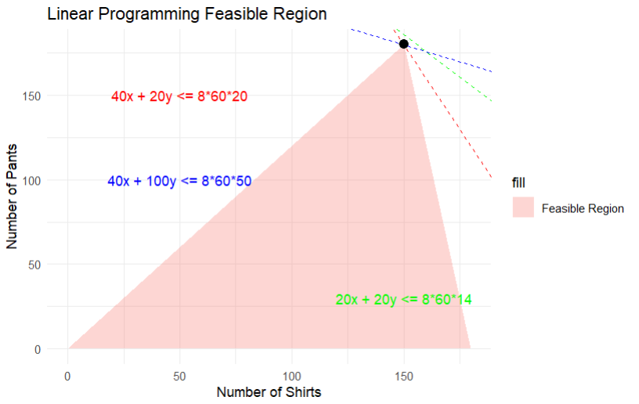

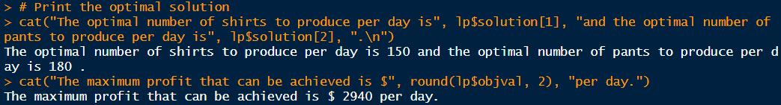

We first solved the equation to fond the correct solution. Using this we created a graph and we can see the results.

Optimal number of Shirts: 150

Optimal number of Pants: 180

Optimal maximum profit: 2940

1. **Find the range for the profit ($) per shirt (if any) that can be obtained without affecting the optimal point of part (c).**

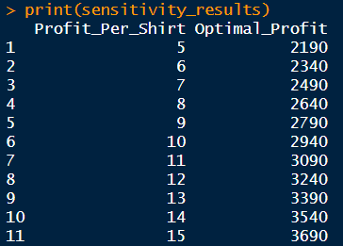

Above table shows range of profit for profit per shirt in different range.

**Question.**

**2. A factory makes three products called Bloom, Amber, and Leaf, from three materials**

**containing Cotton, Wool and Nylon. The following table provides details on the sales**

**price, production cost and purchase cost per ton of products and materials respectively.**

**Sales price Production cost Purchase price**

**Bloom $60 $5 Cotton $40**

**Amber $55 $4 Wool $45**

**Leaf $60 $5 Nylon $30**

**The maximal demand (in tons) for each product, the minimum cotton and wool proportion in each product are as follows:**

**Demand min Cotton proportion min Wool proportion**

**Bloom 4200 50% 40%**

**Amber 3200 60% 40%**

**Leaf 3500 50% 30%**

**a) Formulate an LP model for the factory that maximises the profit, while satisfying the**

**demand and the cotton and wool proportion constraints.**

Let us define the Decision Variables:

b: Tons of Bloom produced

a: Tons of Amber produced

l: Tons of Leaf produced

bc: Tons of Cotton used in Bloom

bw: Tons of Wool used in Bloom

bn: Tons of Nylon used in Bloom

ac: Tons of Cotton used in Amber

aw: Tons of Wool used in Amber

an: Tons of Nylon used in Amber

lc: Tons of Cotton used in Leaf

lw: Tons of Wool used in Leaf

ln: Tons of Nylon used in Leaf

Formulate the Objective Function:

Maximize profit:

Max 15bc + 10bw + 25bn + 11ac + 6aw + 21an + 15lc + 10lw + 25ln

This function sums the profit contributions from each product and material combination.

Specify the Constraints:

Demand Constraints:

b <= 4200 (Bloom demand)

a <= 3200 (Amber demand)

l <= 3500 (Leaf demand)

Material Proportion Constraints:

bc >= 0.5b (Cotton in Bloom)

bw >= 0.4b (Wool in Bloom)

ac >= 0.6a (Cotton in Amber)

aw >= 0.4a (Wool in Amber)

lc >= 0.5l (Cotton in Leaf)

lw >= 0.3l (Wool in Leaf)

Non-Negativity Constraints:

All variables must be non-negative (>= 0)

**b) Solve the model using R/R Studio. Find the optimal profit and optimal values of the decision variables.**

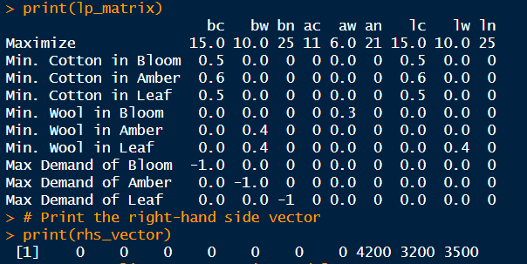

We created a matrix and found total tons of   
Bloom: 4200

Amber: 3200

Leaf: 3500

Max profit if we put in equation: 141850

**3. Two construction companies, Giant and Sky, bid for the right to build in a field. The**

**possible bids are $ 10 Million, $ 20 Million, $ 30 Million, $ 35 Million and $ 40 Million.**

**The winner is the company with the higher bid.**

**The two companies decide that in the case of a tie (equal bids), Giant is the winner and**

**will get the field.**

**Giant has ordered a survey and, based on the report from the survey, concludes that**

**getting the field for more than $ 35 Million is as bad as not getting it (assume loss),**

**except in case of a tie (assume win). Sky is not aware of this survey.**

**(a) State reasons why/how this game can be described as a two-players-zero-sum game**

Two Players: Only Giant and Sky are making decisions.

Zero-sum: If one player gains something, the other loses the same amount. It's like sharing a pie – if one person gets more, the other gets less.

Competitive Nature: Giant and Sky are in a competition. Giant wants to win but has a limit on how much they're willing to pay, while Sky just wants to win, regardless of cost.

Finite Strategies: Both Giant and Sky have only five possible moves they can make, like bidding different amounts of money.

Complete Information for Giant: Giant knows more because they did a survey. Sky doesn't have as much info.

Deterministic Outcome: The result is entirely determined by what Giant and Sky decide. There's no luck involved.

So, this is like a strategic bidding game where one gains what the other loses. Giant has more info, but it's not a perfectly even playing field, which adds a twist to the strategy.

**(b) Considering all possible combinations of bids, formulate the payoff matrix for the**

**game.**

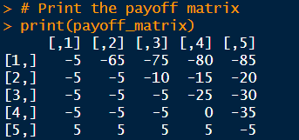

Above table shows us the payoff matrix.  
The matrix accurately reflects the zero-sum nature of the game, as the sum of payoffs in each cell is always zero.

Giant's preference for not exceeding $35M is captured in the payoffs for bids above that amount.

The tie-breaking rule in favor of Giant is reflected in the 0 payoff for a tie at $35M.

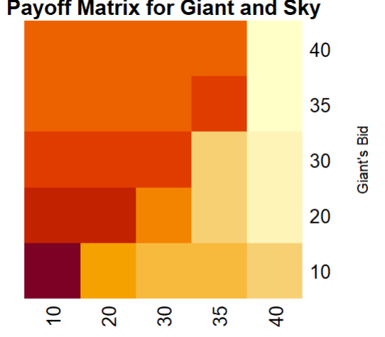

Above is it’s heatmap.

**(c) Explain what is a saddle point. Verify: does the game have a saddle point?**

It's a cell in a payoff matrix where both players' optimal strategies intersect.

It's a stable outcome where neither player has any incentive to deviate from their chosen strategy, even if they know their opponent's strategy.

It's identified by finding the minimum value in each row and the maximum value in each column. If a cell simultaneously represents the minimum value in its row and the maximum value in its column, it's a saddle point.

The game doesn't have a saddle point.

Examining the payoff matrix, there's no cell that meets the criteria for a saddle point.

This means there's no single, stable outcome where both players' optimal strategies align perfectly.

Players will likely need to employ mixed strategies or consider alternative approaches to optimize their outcomes in this game.

**(d) Construct a linear programming model for Company Sky in this game.**

Linear programming model for Company Sky in this game:

Decision Variables:

Let x1, x2, x3, x4, and x5 represent the probabilities that Sky chooses to bid $10M, $20M, $30M, $35M, and $40M, respectively.

Objective Function:

Maximize expected payoff for Sky:

maximize: E = -5x1 - 5x2 - 5x3 - 5x4 + 5x5

Constraints:

Probabilities must sum to 1:

x1 + x2 + x3 + x4 + x5 = 1

Non-negativity:

x1, x2, x3, x4, x5 ≥ 0

The objective function aims to maximize Sky's expected payoff, considering the probabilities of Giant's possible bids.

The constraint ensures that Sky's strategy is a valid probability distribution, with probabilities for each bid summing to 1.

The non-negativity constraints ensure that probabilities cannot be negative.

**(e) Produce an appropriate code to solve the linear programming model in part (d).**

Code file is attached.

**(f) Solve the game for Sky using the linear programming model and the code you constructed in parts (d) and (e). Interpret your solution.**

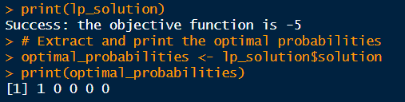

Optimal Bidding Strategy:

The linear programming model suggests that Sky's best strategy is to bid $10 million with a probability of 1 (or 100%).

Objective Function Value:

The objective function value, representing the negative of Sky's expected payoff, is -5. In linear programming, maximizing the negative of the objective function corresponds to finding the highest achievable expected payoff.

Optimal Probabilities:

The optimal probabilities from the model indicate that Sky should bid $10 million with a probability of 1 (100%) and not bid any other amounts.

Alignment with Payoff Matrix:

The result aligns with the payoff matrix, where bidding $10 million consistently emerges as the best strategy for Sky to maximize its expected payoff.

Real-World Considerations:

While the model provides a quantitatively optimized bidding strategy, real-world decisions may involve additional complexities such as competitor behavior, market conditions, and strategic considerations.

Mathematical Optimization Impact:

The application of linear programming techniques highlights the power of mathematical optimization in strategic decision-making, offering valuable insights into optimal bidding strategies.

The linear programming model's results emphasize that, based on the defined payoffs and constraints, Sky's optimal strategy is to consistently bid $10 million with a probability of 1. This approach is supported by the mathematical optimization principles inherent in linear programming. However, it's essential to recognize that real-world bidding decisions may involve nuanced factors beyond the scope of the simplified model.